Ques1: Write a program in Java to print Fibonacci series up to 10 terms.

Source Code

**package** Lab2;

**public** **class** Fibonacci {

**public** **static** **void** main(String[] args) {

System.***out***.println("Hitendra Sisodia");

System.***out***.println("500091910");

**int** h = 1;

**int** l = 0;

System.***out***.println(l);

**while**(h<50) {

System.***out***.println(h);

h = h + l;

l = h - l;

}

}

}

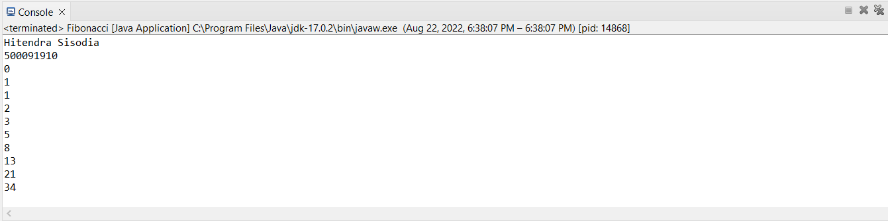 Output

Ques2: Write a program in Java to find out the largest of three numbers.

Source Code

**package** Lab2;

**public** **class** FindMax3Numbers {

**public** **static** **void** main(String[] args) {

System.***out***.println("Hitendra Sisodia");

System.***out***.println("500091910");

**int** a = 20;

**int** b = 5;

**int** c = 3;

**if**(a > b){

**if**(a > c) {

System.***out***.println("Greatest Number is"+a);

}

**else** {

System.***out***.println("Greatest Number is"+c);

}

}

**else** {

**if**(b > c) {

System.***out***.println("Greatest Number is"+b);

}

**else** {

System.***out***.println("Greatest Number is"+c);

}

}

}

}

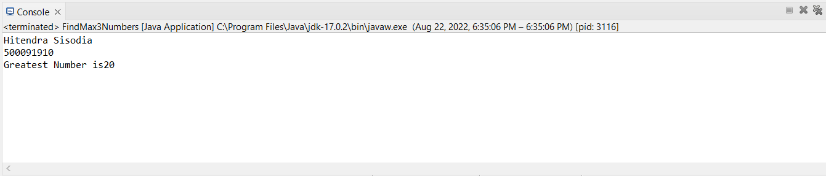  Output

Ques3: Write a program in Java to Find sum of all numbers greater than 40 and less than 250 that are divisible by 5.

Source Code

**package** Lab2;

**public** **class** DivisibleBy5 {

**public** **static** **void** main(String[] args) {

System.***out***.println("Hitendra Sisodia");

System.***out***.println("500091910");

**int** sum = 0;

**int** i = 50;

**int** num = 250;

**while**(i <= num) {

**if**(i % 5 == 0) {

sum = sum + i;

}

i++;

}

System.***out***.println("Sum is:"+sum);

}

}

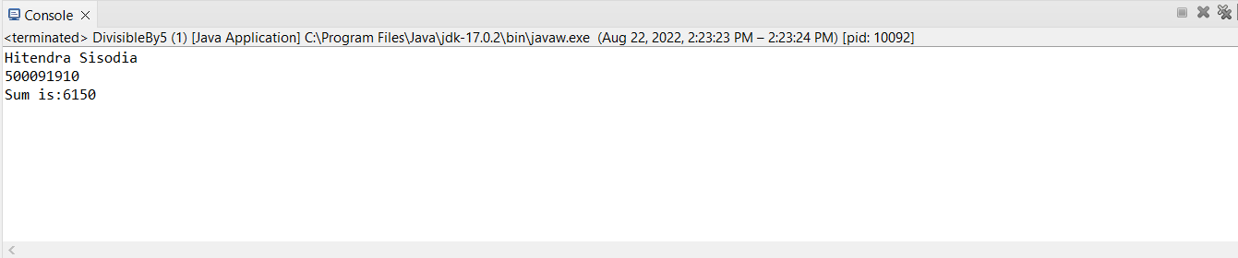 Output

Ques4: Write a program in Java to print the following pattern using loops

*

***

*****

Source Code

**package** Lab2;

**public** **class** Pattern {

**public** **static** **void** main(String[] args) {

System.***out***.println("Hitendra Sisodia");

System.***out***.println("500091910");

**for**(**int** i = 0 ; i < 3 ; i++) {

**for**(**int** j = 0 ; j < 2*i + 1 ; j++) {

System.***out***.print("*");

}

System.***out***.println();

}

}

}

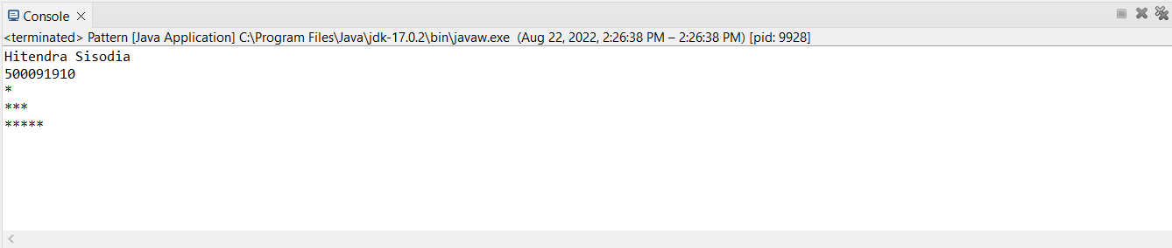 Output